Nama : Pasha Muhammad Nashwan
Nrp : 152023155

PPT 4 Relasi Dalam Java
- Buatkan contoh program yang melibatkan pewarisan
// Kelas induk (superclass)
class Kendaraan {
String merk;
String warna;

// Konstruktor
public Kendaraan(String merk, String warna) {
this.merk = merk;
this.warna = warna;
}

// Metode untuk menampilkan informasi kendaraan
public String info() {
return merk + " berwarna " + warna;
}
}

// Kelas turunan 1 (subclass dari Kendaraan)
class Mobil extends Kendaraan {
int jumlahPintu;

public Mobil(String merk, String warna, int jumlahPintu) {
super(merk, warna); // Memanggil konstruktor superclass
this.jumlahPintu = jumlahPintu;
}

@Override
public String info() {
return "Mobil " + merk + " berwarna " + warna + " dengan " + jumlahPintu + " pintu";
}
}

// Kelas turunan 2 (subclass dari Kendaraan)
class Motor extends Kendaraan {
String jenis;

public Motor(String merk, String warna, String jenis) {
super(merk, warna);
this.jenis = jenis;
}

@Override
public String info() {
return "Motor " + merk + " berwarna " + warna + ", jenis " + jenis;
}
}

// Kelas utama untuk menjalankan program
public class Main {
public static void main(String[] args) {
Mobil mobil1 = new Mobil("Toyota", "Merah", 4);
Motor motor1 = new Motor("Yamaha", "Hitam", "Sport");

System.out.println(mobil1.info());
System.out.println(motor1.info());
}
}

Output pewarisan :
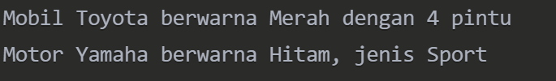

- Buatkan contoh program yang melibatkan Agregasi
// Kelas Mesin (Mesin bisa ada sendiri tanpa Mobil)
class Mesin {
String tipe;

public Mesin(String tipe) {
this.tipe = tipe;
}

public String getTipeMesin() {
return tipe;
}
}

// Kelas Mobil yang memiliki Mesin (Agregasi)
class Mobil {
String merk;
Mesin mesin; // Agregasi: Mobil memiliki Mesin

public Mobil(String merk, Mesin mesin) {
this.merk = merk;
this.mesin = mesin;
}

public void infoMobil() {
System.out.println("Mobil " + merk + " memiliki mesin tipe " + mesin.getTipeMesin());
}
}

// Kelas utama untuk menjalankan program
public class Main {
public static void main(String[] args) {
// Membuat objek Mesin
Mesin mesin1 = new Mesin("V8 Turbo");
Mesin mesin2 = new Mesin("Electric");

// Membuat objek Mobil dengan Mesin yang sudah ada
Mobil mobil1 = new Mobil("Ferrari", mesin1);
Mobil mobil2 = new Mobil("Tesla", mesin2);

// Menampilkan informasi mobil
mobil1.infoMobil();
mobil2.infoMobil();
}
}

Output agregasi :
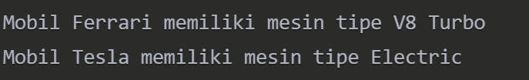

- Buatkan contoh program yang melibatkan komposisi
// Kelas Mesin (Mesin tidak bisa ada tanpa Mobil)
class Mesin {
private String tipe;

public Mesin(String tipe) {
this.tipe = tipe;
}

public String getTipeMesin() {
return tipe;
}
}

// Kelas Mobil yang memiliki Mesin (Komposisi)
class Mobil {
private String merk;
private Mesin mesin; // Komposisi: Mesin dibuat dalam Mobil

public Mobil(String merk, String tipeMesin) {
this.merk = merk;
this.mesin = new Mesin(tipeMesin); // Mesin dibuat di dalam Mobil
}

public void infoMobil() {
System.out.println("Mobil " + merk + " memiliki mesin tipe " + mesin.getTipeMesin());
}
}

// Kelas utama untuk menjalankan program
public class Main {
public static void main(String[] args) {
// Membuat objek Mobil (otomatis membuat Mesin juga)
Mobil mobil1 = new Mobil("Ferrari", "V8 Turbo");
Mobil mobil2 = new Mobil("Tesla", "Electric");

// Menampilkan informasi mobil
mobil1.infoMobil();
mobil2.infoMobil();
}
}

Output komposisi :
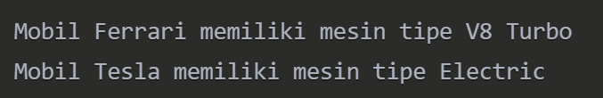

Tugas Kelompok

Point.java
// Point.java
public class Point {
private int x;
private int y;

public Point(int x, int y) {
this.x = x;
this.y = y;
}

public int getX() {
return x;
}

public void setX(int x) {
this.x = x;
}

public int getY() {
return y;
}

public void setY(int y) {
this.y = y;
}

@Override
public String toString() {
return "Point(" + x + ", " + y + ")";
}
}

Shape.java
// Shape.java
public abstract class Shape {
protected String color;

public Shape(String color) {
this.color = color;
}

public abstract void draw();
public abstract void erase();
public abstract void move(int x, int y);
public abstract void resize(double factor);

public String getColor() {
return color;
}

public void setColor(String color) {
this.color = color;
}
}

Circle.java
// Circle.java
public class Circle extends Shape {
private float radius;
private Point center;
private double maxRadius;

public Circle(String color, Point center, float radius) {
super(color);
this.center = center;
this.radius = radius;
this.maxRadius = radius * 2;
}

public void circuit() {
System.out.println("Calculating circle circuit: " + (2 * Math.PI * radius));
}

public void setCenter(Point center) {
this.center = center;
}

public Point getCenter() {
return center;
}

public void setRadius(float radius) {
if (radius <= maxRadius) {
this.radius = radius;
} else {
System.out.println("Radius cannot exceed maximum radius: " + maxRadius);
}
}

public float getRadius() {
return radius;
}

@Override
public void draw() {
System.out.println("Drawing " + color + " Circle at " + center + " with radius " + radius);
}

@Override
public void erase() {
System.out.println("Erasing Circle at " + center);
}

@Override
public void move(int x, int y) {
center.setX(center.getX() + x);
center.setY(center.getY() + y);
System.out.println("Circle moved to " + center);
}

@Override
public void resize(double factor) {
float newRadius = (float)(radius * factor);
if (newRadius <= maxRadius) {
radius = newRadius;
System.out.println("Circle resized to radius " + radius);
} else {
System.out.println("Cannot resize circle beyond max radius: " + maxRadius);
}
}

@Override
public String toString() {
return "Circle[color=" + color + ", center=" + center + ", radius=" + radius + "]";
}
}

Rectangle.java
// Rectangle.java
public class Rectangle extends Shape {
private Point topLeft;
private int width;
private int height;

public Rectangle(String color, Point topLeft, int width, int height) {
super(color);
this.topLeft = topLeft;
this.width = width;
this.height = height;
}

public Point getTopLeft() {
return topLeft;
}

public void setTopLeft(Point topLeft) {
this.topLeft = topLeft;
}

public int getWidth() {
return width;
}

public void setWidth(int width) {
this.width = width;
}

public int getHeight() {
return height;
}

public void setHeight(int height) {
this.height = height;
}

@Override
public void draw() {
System.out.println("Drawing " + color + " Rectangle at " + topLeft +
" with width=" + width + " and height=" + height);
}

@Override
public void erase() {
System.out.println("Erasing Rectangle at " + topLeft);
}

@Override
public void move(int x, int y) {
topLeft.setX(topLeft.getX() + x);
topLeft.setY(topLeft.getY() + y);
System.out.println("Rectangle moved to " + topLeft);
}

@Override
public void resize(double factor) {
width = (int)(width * factor);
height = (int)(height * factor);
System.out.println("Rectangle resized to width=" + width + " and height=" + height);
}

@Override
public String toString() {
return "Rectangle[color=" + color + ", topLeft=" + topLeft +
", width=" + width + ", height=" + height + "]";
}
}

Polygon.java
// Polygon.java
public class Polygon extends Shape {
private Point[] points;

public Polygon(String color, Point[] points) {
super(color);
this.points = points;
}

public Point[] getPoints() {
return points;
}

public void setPoints(Point[] points) {
this.points = points;
}

@Override
public void draw() {
System.out.print("Drawing " + color + " Polygon with points: ");
for (Point p : points) {
System.out.print(p + " ");
}
System.out.println();
}

@Override
public void erase() {
System.out.println("Erasing Polygon");
}

@Override
public void move(int x, int y) {
for (Point p : points) {
p.setX(p.getX() + x);
p.setY(p.getY() + y);
}
System.out.println("Polygon moved");
}

@Override
public void resize(double factor) {
// Mengubah ukuran poligon dari titik pusat
// Pertama cari titik pusat
int sumX = 0, sumY = 0;
for (Point p : points) {
sumX += p.getX();
sumY += p.getY();
}
int centerX = sumX / points.length;
int centerY = sumY / points.length;

// Lalu ubah ukuran setiap titik dari titik pusat
for (Point p : points) {
int dx = p.getX() - centerX;
int dy = p.getY() - centerY;
p.setX(centerX + (int)(dx * factor));
p.setY(centerY + (int)(dy * factor));
}
System.out.println("Polygon resized by factor " + factor);
}

@Override
public String toString() {
StringBuilder sb = new StringBuilder("Polygon[color=" + color + ", points=");
for (Point p : points) {
sb.append(p).append(" ");
}
sb.append("]");
return sb.toString();
}
}

Event.java
// Event.java
public class Event {
private String eventType;
private long timestamp;

public Event(String eventType) {
this.eventType = eventType;
this.timestamp = System.currentTimeMillis();
}

public String getEventType() {
return eventType;
}

public long getTimestamp() {
return timestamp;
}

@Override
public String toString() {
return "Event[type=" + eventType + ", timestamp=" + timestamp + "]";
}
}

Frame.java
// Frame.java
public class Frame {
private String title;
private int width;
private int height;

public Frame(String title, int width, int height) {
this.title = title;
this.width = width;
this.height = height;
}

public String getTitle() {
return title;
}

public void setTitle(String title) {
this.title = title;
}

public int getWidth() {
return width;
}

public void setWidth(int width) {
this.width = width;
}

public int getHeight() {
return height;
}

public void setHeight(int height) {
this.height = height;
}

@Override
public String toString() {
return "Frame[title=" + title + ", width=" + width + ", height=" + height + "]";
}
}

Window.java
// Window.java
import java.util.ArrayList;
import java.util.List;

public class Window extends Frame {
private List<Shape> shapes;
private List<Event> events;

public Window(String title, int width, int height) {
super(title, width, height);
shapes = new ArrayList<>();
events = new ArrayList<>();
}

public void open() {
System.out.println("Opening window: " + getTitle());
handleEvent(new Event("WINDOW_OPEN"));
}

public void close() {
System.out.println("Closing window: " + getTitle());
handleEvent(new Event("WINDOW_CLOSE"));
}

public void move() {
System.out.println("Moving window: " + getTitle());
handleEvent(new Event("WINDOW_MOVE"));
}

public void display() {
System.out.println("Displaying window: " + getTitle() + " (" + getWidth() + "x" + getHeight() + ")");
System.out.println("Shapes in the window:");
for (Shape shape : shapes) {
shape.draw();
}
}

public void handleEvent(Event event) {
events.add(event);
System.out.println("Handled event: " + event);
}

public void addShape(Shape shape) {
shapes.add(shape);
System.out.println("Added shape: " + shape);
}

public void removeShape(Shape shape) {
shapes.remove(shape);
System.out.println("Removed shape: " + shape);
}

public List<Shape> getShapes() {
return shapes;
}

public List<Event> getEvents() {
return events;
}
}

DrawingContext.java
// DrawingContext.java
public class DrawingContext {
private int width;
private int height;

public DrawingContext(int width, int height) {
this.width = width;
this.height = height;
}

public void setPoint(int x, int y) {
System.out.println("Setting point at (" + x + ", " + y + ")");
}

public void clearScreen() {
System.out.println("Clearing screen");
}

public int getVerticalSize() {
return height;
}

public int getHorizontalSize() {
return width;
}
}

ComdeWindow.java
// ComdeWindow.java
public class ComdeWindow extends Window {
private DrawingContext drawingContext;

public ComdeWindow(String title, int width, int height) {
super(title, width, height);
this.drawingContext = new DrawingContext(width, height);
}

public DrawingContext getDrawingContext() {
return drawingContext;
}

public void setDrawingContext(DrawingContext drawingContext) {
this.drawingContext = drawingContext;
}

@Override
public void display() {
System.out.println("ComdeWindow display:");
drawingContext.clearScreen();
super.display();
}
}

DialogBox.java
// DialogBox.java
public class DialogBox extends Window {
private String message;
private boolean modal;

public DialogBox(String title, int width, int height, String message, boolean modal) {
super(title, width, height);
this.message = message;
this.modal = modal;
}

public String getMessage() {
return message;
}

public void setMessage(String message) {
this.message = message;
}

public boolean isModal() {
return modal;
}

public void setModal(boolean modal) {
this.modal = modal;
}

@Override
public void display() {
System.out.println("DialogBox: " + getTitle());
System.out.println("Message: " + message);
System.out.println("Modal: " + modal);
super.display();
}
}

DataController.java
// DataController.java
import java.util.ArrayList;
import java.util.List;

public class DataController {
private List<Object> data;
private DialogBox dialog;

public DataController(DialogBox dialog) {
this.dialog = dialog;
this.data = new ArrayList<>();
}

public void addData(Object item) {
data.add(item);
System.out.println("Added data: " + item);
}

public void removeData(Object item) {
if (data.remove(item)) {
System.out.println("Removed data: " + item);
} else {
System.out.println("Item not found: " + item);
}
}

public List<Object> getData() {
return data;
}

public void showDialog(String message) {
dialog.setMessage(message);
dialog.display();
}

public DialogBox getDialog() {
return dialog;
}
}

Main.java
// Main.java
public class Main {
public static void main(String[] args) {
// Membuat jendela utama aplikasi
ComdeWindow mainWindow = new ComdeWindow("Aplikasi Gambar", 800, 600);

// Membuat dialog box
DialogBox dialog = new DialogBox("Info", 300, 200, "Selamat datang di aplikasi gambar!", false);

// Membuat controller data
DataController controller = new DataController(dialog);

// Membuat bentuk-bentuk
Point p1 = new Point(100, 100);
Point p2 = new Point(200, 200);
Point p3 = new Point(300, 100);

Circle circle = new Circle("Merah", p1, 50);
Rectangle rectangle = new Rectangle("Biru", p2, 150, 80);

Point[] polygonPoints = {
new Point(400, 100),
new Point(500, 150),
new Point(450, 200),
new Point(350, 180)
};
Polygon polygon = new Polygon("Hijau", polygonPoints);

// Menampilkan jendela
System.out.println("===== DEMONSTRASI APLIKASI =====");
System.out.println();

// Menambahkan bentuk ke jendela
mainWindow.addShape(circle);
mainWindow.addShape(rectangle);
mainWindow.addShape(polygon);

// Menampilkan isi jendela
mainWindow.display();
System.out.println();

// Mendemonstrasikan modifikasi bentuk
System.out.println("===== MODIFIKASI BENTUK =====");
circle.setRadius(75);
circle.move(50, 50);
rectangle.resize(1.5);
polygon.setColor("Ungu");

mainWindow.display();
System.out.println();

// Demonstrasi pesanan dari pengguna ("Si A memesan apa saja")
System.out.println("===== DEMONSTRASI PESANAN =====");
controller.addData("Pesanan dari User A");
controller.addData(circle);
controller.addData(rectangle);

// Tampilkan info pesanan
controller.showDialog("User A memesan 2 bentuk: lingkaran dan persegi panjang");

System.out.println("\nData pesanan dalam controller:");
for (Object item : controller.getData()) {
System.out.println("- " + item);
}

// Menutup aplikasi
System.out.println("\n===== MENUTUP APLIKASI =====");
mainWindow.close();
}
}

Output :
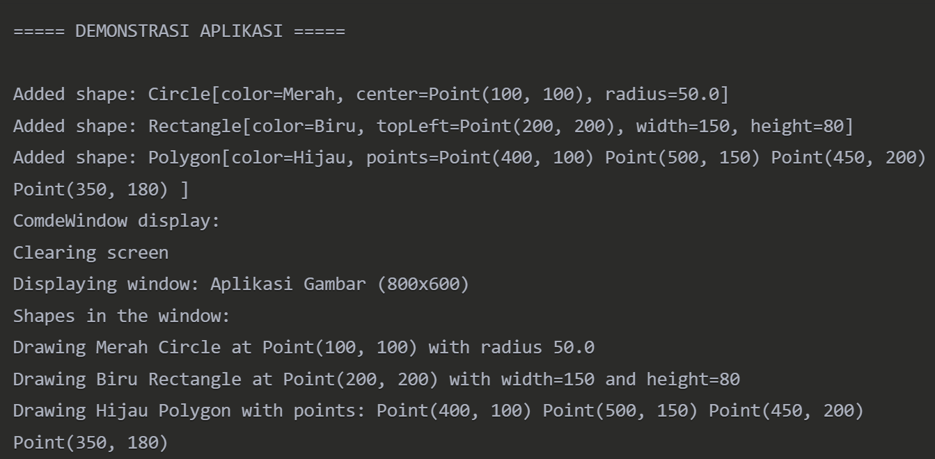
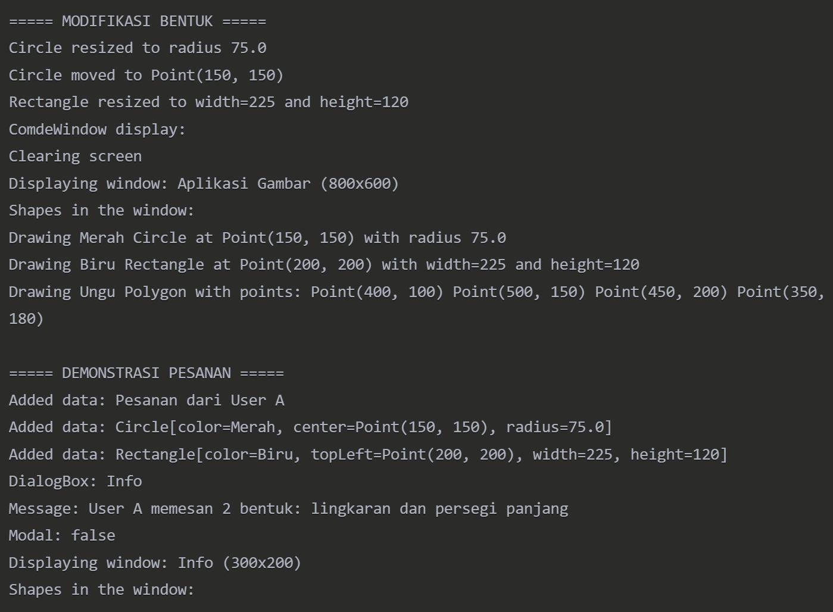
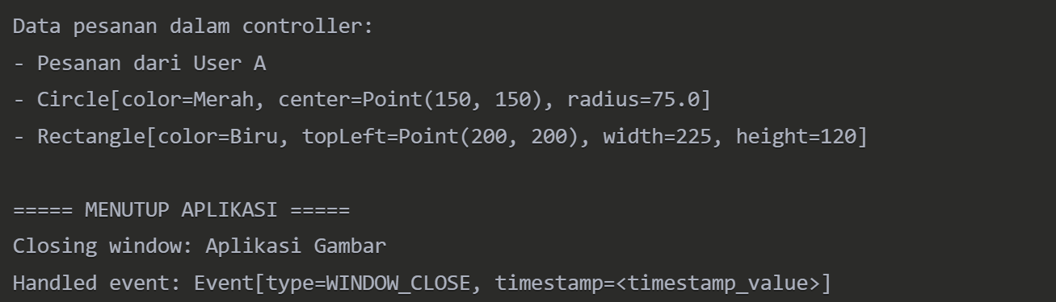
Tugas PPT 5 Inherintace

1. Multilevel Inheritance
class Animal {
void eat() {
System.out.println("eating...");
}
}

class Dog extends Animal {
void bark() {
System.out.println("barking...");
}
}

class BabyDog extends Dog {
void weep() {
System.out.println("weeping...");
}
}

class TestMultilevelInheritance {
public static void main(String args[]) {
BabyDog b = new BabyDog();
b.weep(); // dari BabyDog
b.bark(); // diwarisi dari Dog
b.eat(); // diwarisi dari Animal
}
}

Output :
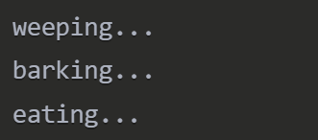
2. Hieralchical
class Animal {
void eat() {
System.out.println("eating...");
}
}

class Dog extends Animal {
void bark() {
System.out.println("barking...");
}
}

class Cat extends Animal {
void meow() {
System.out.println("meowing...");
}
}

class Cow extends Animal {
void moo() {
System.out.println("mooing...");
}
}

class TestHierarchicalInheritance {
public static void main(String args[]) {
Dog d = new Dog();
d.bark();
d.eat(); // diwarisi dari Animal

Cat c = new Cat();
c.meow();
c.eat(); // diwarisi dari Animal

Cow cow = new Cow();
cow.moo();
cow.eat(); // diwarisi dari Animal
}
}

Output :
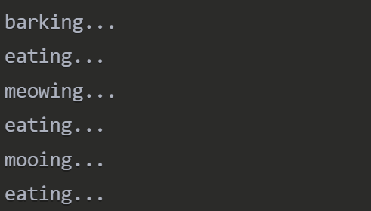

3. Implementing Multiple inheritence
interface Printable {
void print();
}

interface Showable {
void show();
}

class Animal {
void eat() {
System.out.println("eating...");
}
}

// MyClass mewarisi dari Animal dan mengimplementasikan dua interface
class MyClass extends Animal implements Printable, Showable {
public void print() {
System.out.println("printing...");
}

public void show() {
System.out.println("showing...");
}
}

class TestMultipleInheritance {
public static void main(String args[]) {
MyClass obj = new MyClass();
obj.eat(); // dari class Animal
obj.print(); // dari interface Printable
obj.show(); // dari interface Showable
}
}

Output :
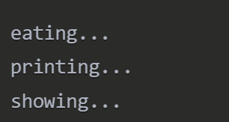

4. super() can be used to invoke immediate parent class constructor.
class Animal {
Animal() {
System.out.println("Animal constructor called");
}

void eat() {
System.out.println("eating...");
}
}

class Dog extends Animal {
Dog() {
super(); // Memanggil constructor dari Animal
System.out.println("Dog constructor called");
}

void bark() {
System.out.println("barking...");
}
}

class TestSuperConstructor {
public static void main(String args[]) {
Dog d = new Dog(); // Saat objek Dog dibuat, constructor Animal dipanggil dulu
d.eat();
d.bark();
}
}

Output :
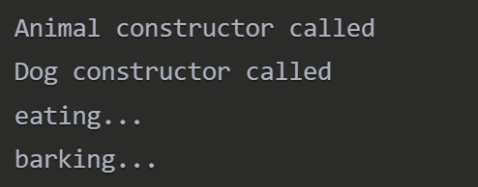

Tugas PPT 6 Polymorphism

- Implementasikan 2 cara overloading

- Overloding Metode (luas) dalam kelas Bangundatar
class BangunDatar:
def luas(self, a, b=None):
if b is None:
# Persegi
return a * a
else:
# Persegi Panjang
return a * b

bd = BangunDatar()
print("Luas Persegi:", bd.luas(4)) # Output: 16
print("Luas Persegi Panjang:", bd.luas(4, 6)) # Output: 24

Output overloading methode :
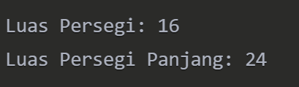

- Overloding Konstruktor
class Mahasiswa:
def __init__(self, nama=None, umur=None):
if nama and umur:
print(f"Mahasiswa bernama {nama}, umur {umur}")
elif nama:
print(f"Mahasiswa bernama {nama}")
else:
print("Mahasiswa tanpa data")

m1 = Mahasiswa("Raka", 18)
m2 = Mahasiswa("Tina")
m3 = Mahasiswa()
Output overloading konstructor :
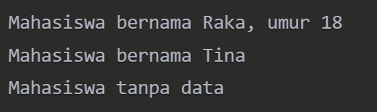

- Overriding
class Hewan:
def suara(self):
print("Hewan bersuara")

class Kucing(Hewan):
def suara(self):
print("Meong~")

class Anjing(Hewan):
def suara(self):
print("Guk guk!")

# Polymorphism dinamis saat runtime
hewan1 = Kucing()
hewan2 = Anjing()

hewan1.suara() # Output: Meong~
hewan2.suara() # Output: Guk guk!

Output :

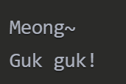

Tugas PPT 7 Abstraction & Encapsulation

- Implementasikan Abstract class dan Interface dalam Java
// Interface
interface Kendaraan {
void nyalakanMesin();
void matikanMesin();
}

// Abstract Class
abstract class Mobil implements Kendaraan {
String merk;

public Mobil(String merk) {
this.merk = merk;
}

// Method abstract
abstract void bukaPintu();

// Method non-abstract
public void info() {
System.out.println("Merk Mobil: " + merk);
}
}

// Subclass yang meng-extend Abstract Class
class Sedan extends Mobil {
public Sedan(String merk) {
super(merk);
}

@Override
void bukaPintu() {
System.out.println("Pintu sedan dibuka ke samping.");
}

@Override
public void nyalakanMesin() {
System.out.println("Mesin sedan dinyalakan.");
}

@Override
public void matikanMesin() {
System.out.println("Mesin sedan dimatikan.");
}
}

// Program utama
public class AbstractClassDanInterface {
public static void main(String[] args) {
Sedan sedanKu = new Sedan("Toyota Vios");
sedanKu.info();
sedanKu.nyalakanMesin();
sedanKu.bukaPintu();
sedanKu.matikanMesin();
}
}

Output Abstract Class and Interface :
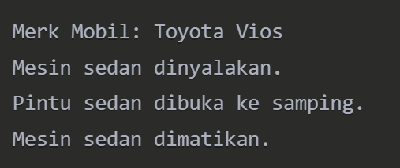

- buatkan contoh program dengan protected modifier

karyawan.java
package perusahaan;

public class Karyawan {
protected String nama;
protected int gaji;

public Karyawan(String nama, int gaji) {
this.nama = nama;
this.gaji = gaji;
}

protected void tampilkanData() {
System.out.println("Nama: " + nama);
System.out.println("Gaji: " + gaji);
}
}

Manager.java
package perusahaan;

public class Manager extends Karyawan {
private int bonus;

public Manager(String nama, int gaji, int bonus) {
super(nama, gaji);
this.bonus = bonus;
}

public void tampilkanDataManager() {
// Memanggil method protected dari superclass
tampilkanData();
System.out.println("Bonus: " + bonus);
}
}

MainProgram.java
package perusahaan;

public class MainProgram {
public static void main(String[] args) {
Manager manager1 = new Manager("Rudi", 8000000, 2000000);
manager1.tampilkanDataManager();
}
}

Output Protected Modifier :
